Marine Science: Enabling the UK community to come together

The UK’s marine science community organisations include the Marine Alliance for Science and Technology for Scotland (MASTS), the National Oceanography Centre (NOC) Association of Marine Science National Capability Beneficiaries (NOCA) and the Challenger Society for Marine Science.

The membership of the NOCA Steering Board decided to create an overview of these organisations to help clarify their remits and explain how they work together.

The Marine Alliance for Science and Technology for Scotland (MASTS)

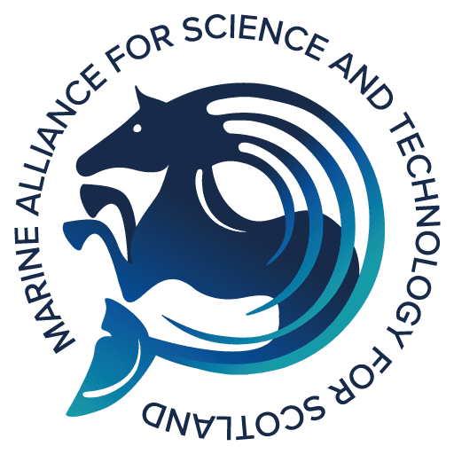
Formed in 2009, MASTS is now a consortium of 18 organisations engaged in marine science including 13 Higher Education Institutions and five Government and Non-Governmental Departmental Bodies with remits in the marine environment. MASTS represents more than 900 researchers both nationally and internationally and includes the majority of Scotland's marine research capacity, people, and infrastructure. In 2023 MASTS welcomed its first non-Scottish institution, the University of Essex as a new member to the MASTS family. MASTS is structured around three major research Themes:

- Dynamics and properties of marine systems.
- Productive seas; and
- Biodiversity, ecosystem function and services.

MASTS is in the process of evolving its science structure to build on existing successful cognate research Forums by creating dedicated Working Groups designed to address key challenges in the marine environment (https://masts.ac.uk/research/research-forums/).

MASTS continues to raise the profile of its research community wherever possible and particularly at domestic and international governmental levels. It supports targeted outreach activities delivered by MASTS members and its Annual Science Meeting is the largest UK marine research gathering. MASTS hosts the Scottish Universities Partnership for Doctoral Training (SUPER DTP) and the MASTS Executive and Operations Directors, Champion the UK Sustainable Management of UK Marine Resources programme on behalf of NERC and the ESRC.

The National Oceanography Centre (NOC) Association of Marine Science National Capability Beneficiaries (NOCA)
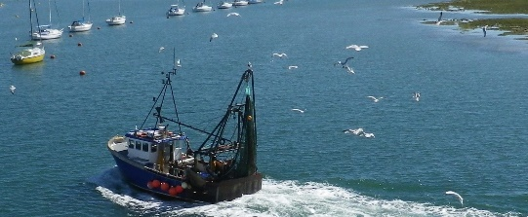
The NOCA is the main vehicle for NOC’s engagement with the beneficiaries of NOC-led marine science National Capability (NC). NC comprises: science, large-scale research infrastructure, small-scale NC-services, facilities and data and National and Public Good.
The NOC leads all marine science NC, working in partnership with our Delivery Partners - the Plymouth Marine Laboratory, the Scottish Association for Marine Science and the Continuous Plankton Recorder Programme delivered by the Marine Biological Association.​

The NOCA also provides advice to the NOC on wider issues such as the NOC’s role in providing wider national and international leadership; helping convene and coordinate marine science in the UK, and strategic horizon scanning.

The Marine Facilities Advisory Board and Climate Linked Atlantic Sector Science Advisory Board come under the umbrella of the NOCA.
The National Oceanography Centre Association is a strategic platform that brings together the Natural Environment Research Council (NERC) funded marine science community to enhance its influence on funders, policy makers and the impact that science has on society.
The NOC Association provides a channel to seek input and share outputs and information with the wider marine science community and its stakeholders. As such, the NOC Association is responsive to the needs and suggestions of its members.

The Challenger Society for Marine Science
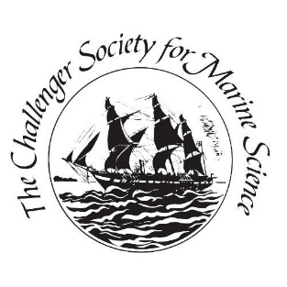
The Challenger Society for Marine Science is a learned society for marine scientists and is named after the ship H.M.S. Challenger, which was used in one of the most important marine studies ever conducted.

Society objectives:

- to advance the study and application of marine science through research and education
- to encourage collaboration between the marine science research base and industry/commerce
- to contribute to public debate and government policy on the development of marine science
- to hold regular meetings about marine science
- to set up specialist groups
- to provide a forum for deeper technical discussions
- to disseminate knowledge to the public to encourage a wider interest in the study of the seas and an awareness of the need for their proper management
- to publish news of the activities of the Society and the world of marine science; material intended to present new activities and developments in a way to bring them to public attention
- to provide or arrange, in suitable cases, financial assistance to students in marine science.

Achieved by:-
- holding regular scientific meetings
- supporting specialist groups to enable discussion and by publishing a magazine and newsletter
- fostering links to groups and societies throughout the world
- operating a travel grant and stepping stones bursary scheme
- its biannual award of Challenger Fellowships and the Challenger Medal.

The Society’s biannual UK Challenger Conference is attended by hundreds of researchers from the UK and world-wide with an associated marine science technology exhibition. Challenger’s affiliated groups organise meetings to discuss topics and enable PhD students and senior scientists to present their latest research.
The Society publishes the twice-yearly Ocean Challenge and a monthly newsletter for members, supports early career members through bursary and travel grant schemes and contributes to policy advice to government and learned bodies.
How MASTS, the NOCA and the Challenger Society work together

A key way in which these groups work together is in information sharing to ensure that the community is kept informed on latest National Capability (NC), science and technology developments.

The NOCA Steering Board includes members from MASTS and the Challenger Society and the Chair of the NOCA also sits on the Council of the Challenger Society as a co-opted member.

The Board considers topics that may impact the community to identify the most appropriate route for discussion. A recent example is the 2020 survey on the impacts of COVID 19 on the UK Marine Science Community. This survey was shared by the secretariats of the NOCA, MASTS and the Challenger Society and was open to the UK marine science and technology community. Issues raised related to access to NC, fieldwork, conferences, teaching and education etc., spanning the remit of all three groups.

For further information on our roles:

The Marine Alliance for Science and Technology for Scotland (MASTS)

Professor David Paterson, MASTS Executive Director - dp1@st-andrews.ac.uk
Dr Mark James, MASTS Operations Director - maj8@st-andrews.ac.uk

The National Oceanography Centre (NOC) Association of Marine Science National Capability Beneficiaries (NOCA)

Professor Mark Inall, Chair of the NOCA - Mark.Inall@sams.ac.uk
Jackie Pearson, NOCA Secretary - jfpea@noc.ac.uk

The Challenger Society

Professor Mike Meredith, President of the Challenger Society - mmm@bas.ac.uk
Dr Kate Hendry – Honorary Secretary of the Challenger Society - kathen@bas.ac.uk

