NOC Association of Marine Science National Capability Beneficiaries (NOCA)

15th AGM (Online): 19th – 20th May 2026

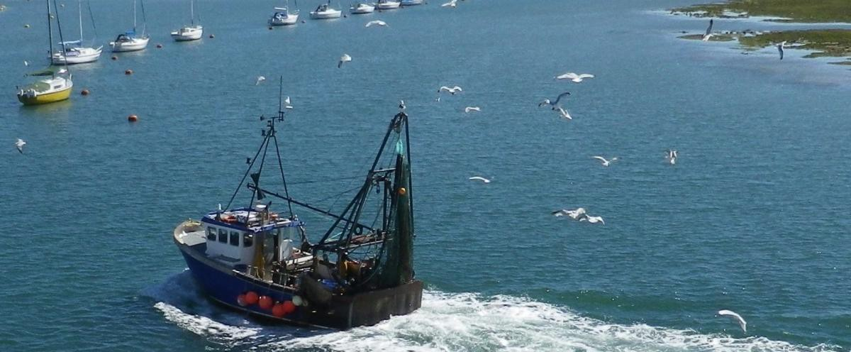

Professor Martin Solan, Chair of the NOCA, and the members of the NOCA Steering Board look forward to joining colleagues from member institutes of the NOC Association of Marine Science National Capability Beneficiaries (NOCA), the Marine Alliance Science for Science and Technology for Scotland (MASTS) and the Challenger Society for the 2026 AGM of the NOCA. You don’t have to be a member of these groups to participate—anyone with an interest in the marine environment is welcome.

This event is free and will be conducted online by Zoom as follows:

Tuesday 19 May 2026 10:00 – 12:15

Wednesday 20 May 2026 10:00 – 12:15

This year’s AGM will include presentations on the role of the NOC Association, updates on Marine Science UK (MSUK), the Marine Facilities Advisory Board, shaping the future of the UK’s national marine science capabilities and infrastructure, the Atlantic Climate and Environment Strategic Science (AtlantiS) programme, the Antarctica InSync Programme, how NERC’s funding landscape is changing, and the Horizon Europe programme and UK engagement.

To participate in the 2026 NOCA AGM please register here.

