NOC Association of Marine Science National Capability Beneficiaries (NOCA)

12th Annual Meeting 7 - 8 June 2023

Virtual Meeting
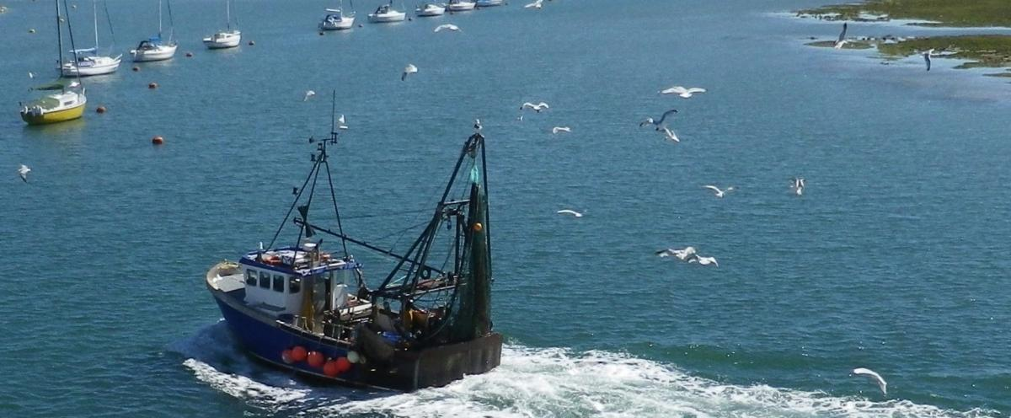
Professor Mark Inall and the membership of the NOCA Steering Board look forward to joining colleagues from member institutes of the NOC Association of Marine Science National Capability Beneficiaries (NOCA), the Marine Alliance Science for Science and Technology for Scotland (MASTS), the Challenger Society and the Global Environmental Research Committee (GERC) at the 2023 AGM of the NOCA. You don’t have to be a member of these groups to participate – anyone with an interest in the marine environment is welcome.
This free on-line event will be conducted by Zoom on 7 - 8 June 2023 between 10:00 and 12:30 on both dates. Delegates will be asked to log on by 09:45 each day to ensure we are ready to start at 10:00.

Agenda
Wednesday 7th June 2023 10:00 UK time

09:30 – 09:45 Delegates invited to log on

10:00 Welcome from Professor Mark Inall, Chair

10:05 Accessibility to marine research – Dr Eleanor Darlington

10:15 Questions
___________________________________________________________________
10:30 Rebidding of Long-Term Large Scale Single Sector (LTSS) National Capability – Dr John Siddorn

10:45 Questions

11:00 Break

11:15 The National Marine Facilities (NMF) Technology Roadmap –
Helen Oldridge

11:30 Questions
___________________________________________________________________

11:45 UN Decade of Ocean Sciences for Sustainable Development:
The UK Decade Working Group (DWG)

Questions to Professor Willie Wilson
___________________________________________________________________

11:50 General closing questions from the floor

An opportunity for closing thoughts/questions from delegates.

12:00 Close of day two

Thursday 8th June 2023 10:00 UK time

09:30 – 09:45 Delegates invited to log on

10:00 Welcome from Professor Mark Inall

10:05 Outcome of the UK Sustained Scientific Ocean Observation
Priorities Consultation (SSOOP) – Professor Ed Hill

10:30 Questions
___________________________________________________________________

10:45 NERC’s Environmental Data Service – Dr John Siddorn

11:00 Questions
11:15 Break
___________________________________________________________________

11:30 Upscaling Autonomy Working Group - Professor Mark Inall

11:40 Questions
___________________________________________________________________

11:45 Rock Store Working Group – Dr Suzanne MacLachlan

11:55 Questions
___________________________________________________________________

12:00 General questions from the floor

An opportunity for closing thoughts/questions from delegates.

12:10 Close of day two

___________________________________________________________________

Registration
To participate in the 12th NOCA AGM please register here.

